Introduction

I wrote a program that classified and sorted different images of animals (cats and dogs) using a recursive method

Proposed solution

At first, I attempted to solve the problem as normal as I would (without using recursion) in order to understand fully of what was expected of me. After using for loops and a method called os.walk, I began to change the code I had into a recursive method. All I did was replace my original os.walk with a recursive call by changing the parameters of the original method. My code is able to traverse through all the files and directories by calling itself each time it cannot find a directory. It classifies the images by using the method provided by Diego that gives the image a value of 0.0 – 1.0, the close the value is to one the closer it is to being a dog and vice versa. A simple if statement checked the value and assorted it into the correct array. In order to call itself it would check if there is a directory and iterate through the method until there was not one, it would then change the path to a new directory and do the process all over again until it was done. In order to check if it was correct I implanted a function to print the elements in cat list and dog list when it was done iterating.

Experimental results

The test cases were a little difficult to implement in this code since it is based on directories and files. I found that messing with the files and directories themselves would be the best way to test my code since, the code is dependent on those files. First test was simply going over to ‘DCIM’ folder and deleting it then running the program. I then deleted the images in ‘All’, leaving an empty folder and ran the program again to see the desired output (Not showing All or DCIM). For the last test case I then moved ‘Main’ to a different folder, this time inside ‘Pictures’ (by dragging ‘Main’ file) instead of being in ‘CatsandDogs’.

SAMPLE #1 DELETING ‘DCIM’ : (No ‘DCIM’ folder shown)

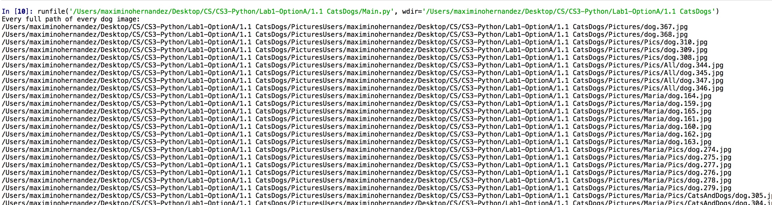

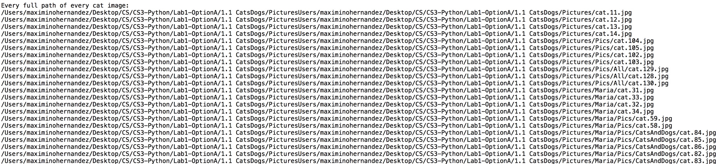

SAMPLE #2 Deleting all files in ‘All’: (No ‘All’ folder shown)

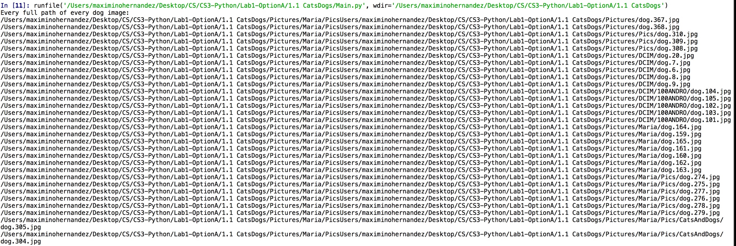

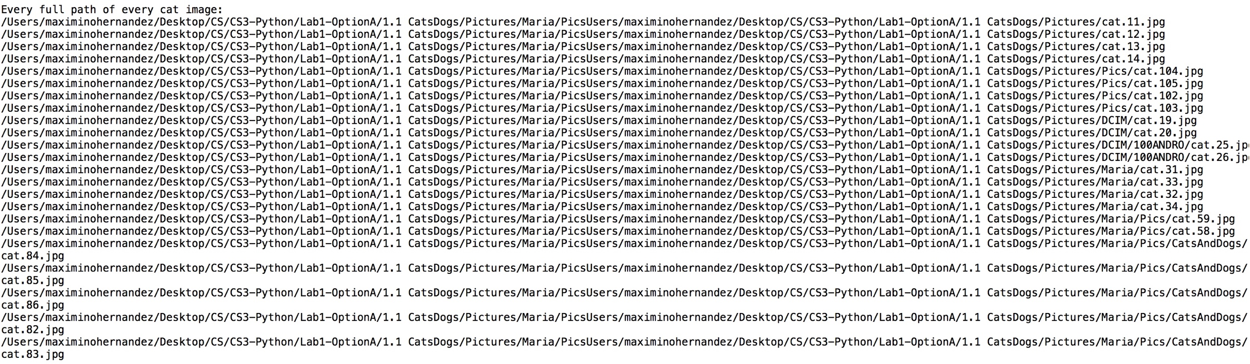

SAMPLE #3 Normal

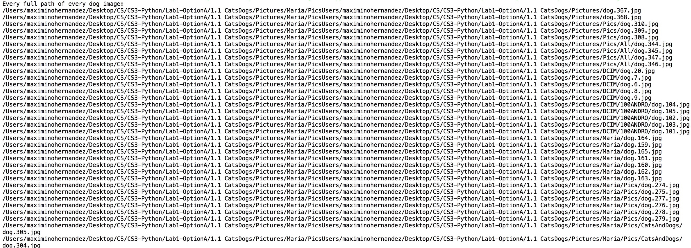

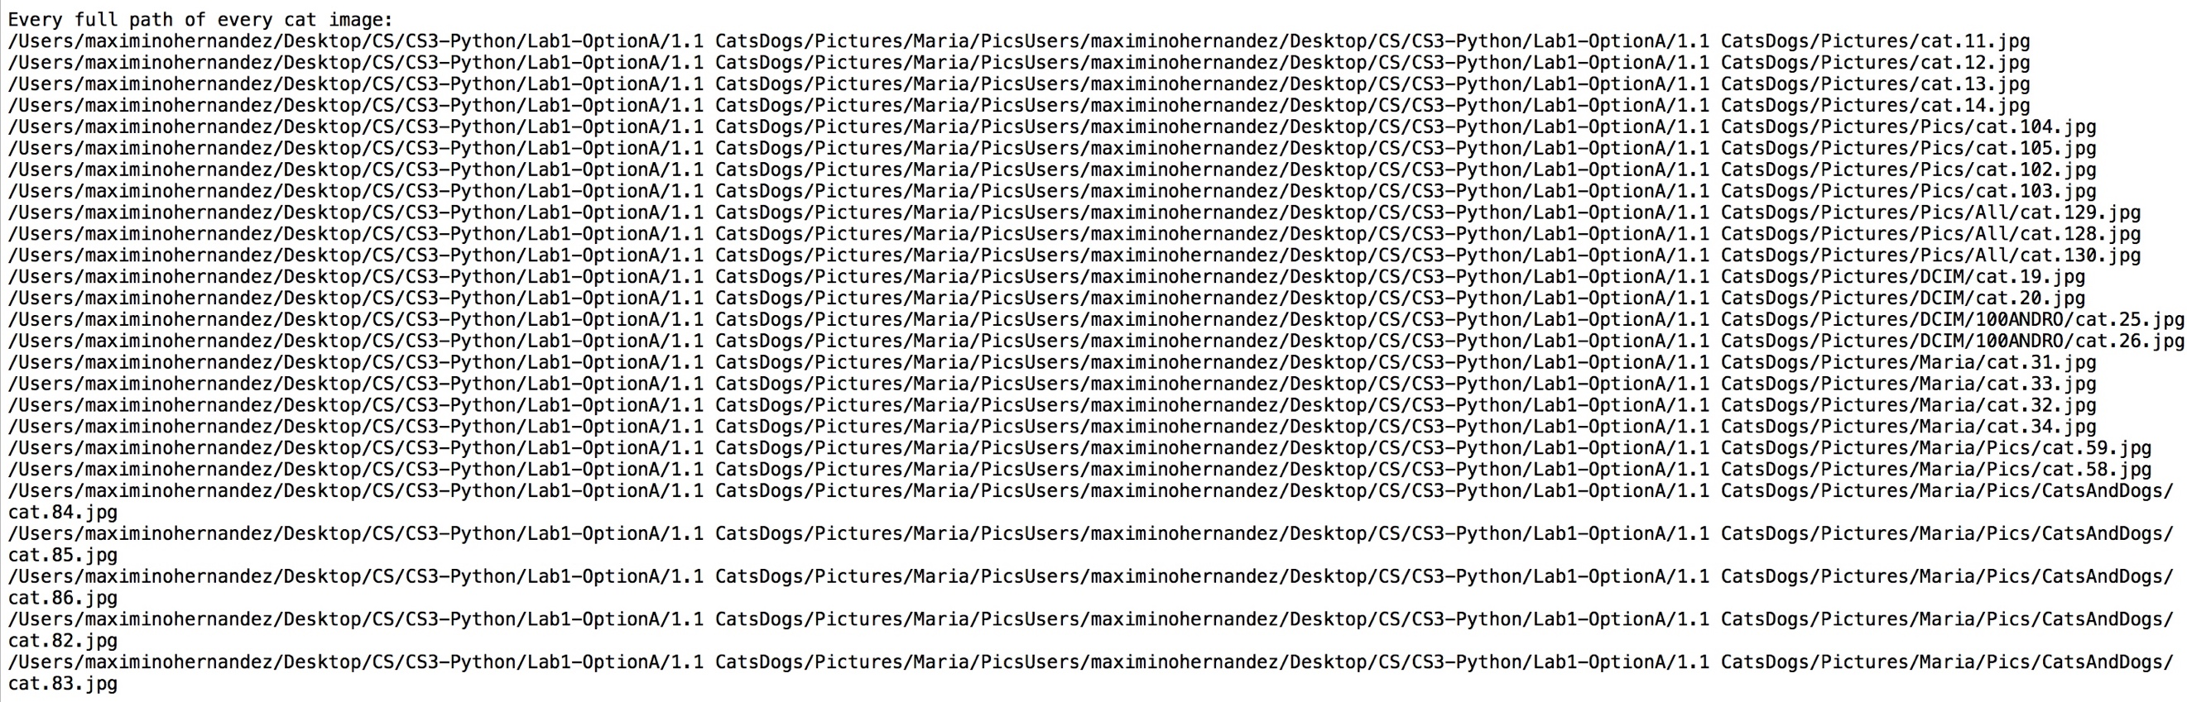

•Conclusions

I learned how to recursively traverse through files and directories and how to read and identify each one in Python. Since I had no Python knowledge before starting this lab, I had to learn Python syntax and functions in order to complete this assignment. I also learned how to print the whole path to an image and how to sort files into lists.

•Appendix

#Jesus Maximino Hernandez 88756947

#Data Structures - Diego Aguirre

#Lab 1 - Option A

#Program classifys and sorts mages of animals

import os

import random

def get_dirs_and_files(path):

dir_list = [directory for directory in os.listdir(path) if os.path.isdir(path + '/' + directory)]

file_list = [directory for directory in os.listdir(path) if not os.path.isdir(path + '/' + directory)]

return dir_list, file_list

#determines if image is a dog or cat

def classify_pic(path):

# To be implemented by Diego: Replace with ML model

if "dog" in path:

return 0.5 + random.random() / 2

return random.random() / 2

#count variable to count how many times process_dir() method iterates

count = 0

#Method to sort images into cat or dog list

def process_dir(path, cat_list, dog_list):

global count

dir_list, file_list = get_dirs_and_files(path)

#Goes through directories and files

for f in file_list:

#Condition to ignore unwanted files

if f[0] is not '.' and f[0] is not 'M' and f[0] is not '~' :

#method to classify whether image is dog or cat image and put it into its proper list

if classify_pic(f) < .5:

cat_list.append(os.path.join(path, f))

else:

dog_list.append(os.path.join(path, f))

#Recursive call to iterate through all the directories and files

for directory in dir_list:

process_dir(os.path.join(path, directory), cat_list, dog_list)

#print elements in cat_list and dog_list

if count == 5:

print ("Every full path of every dog image:" )

for x in range(len(dog_list)):

print (path + dog_list[x][1:])

print()

print ("Every full path of every cat image:" )

for x in range(len(cat_list)):

print (path + cat_list[x][1:])

count = count + 1

return cat_list, dog_list

def main():

start_path = os.getcwd()# current directory

process_dir(start_path, [], []),

main()

#TEST CASES:

#Initated differnet tests by : deleting directories and images ('DCIM' and all files in 'All', moving program to a differnt location

#(Ex: Inside 'Pictures' and adding a word documebt in 'Pictures' folder)

“I certify that this project is entirely my own work. I wrote, debugged, and tested the code being presented, performed the experiments, and wrote the report. I also certify that I did not share my code or report or provided inappropriate assistance to any student in the class.”